COINS-A000-Constans-Emperor in a galley-Thessalonica Mint. 337 - 350 CE.

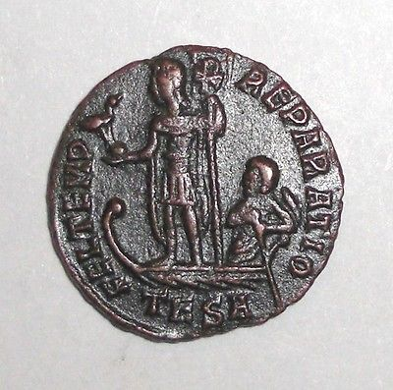 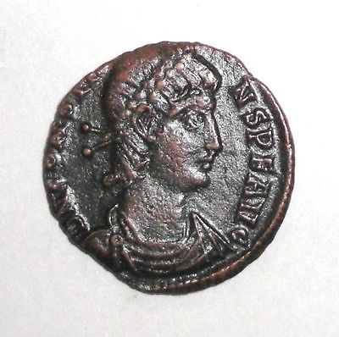

- Constans. 337 - 350 AD. Thessalonica Mint. Emperor in a galley piloted by Victory. 17.58mm, 1.74g.